**Curriculum**

**Policy**

**CURRICULUM POLICY**

To be read in conjunction with:

* Assessment Policy
* Accessibility Policy & Plan
* SEND Policy
* Educational Visits Policy
* Careers Education and Guidance Policy
* Marking and Feedback Policy
* SMSC Policy

Policy Review Date: September 2025

**Contents**

1. **Introduction**
2. **Curriculum Intent**
3. **Curriculum Implementation**
4. **Curriculum Impact**

**Introduction**

Benton House is a school for boys and girls aged 5 to 14 who exhibit a range of complex needs, including communication difficulties, social, emotional and mental health needs and pupils who have been diagnosed with autism or demonstrate behaviours associated with autism. Pupils are placed from a wide range of local authorities, and they all have an Education, Health and Care Plan (EHCP). Before joining our school, and because of their behavioural and emotional difficulties and/or associated learning needs, many were unable to access an educational curriculum effectively.

Our School is a learning environment at the heart of its wider community. We promote the care of our pupils - setting, respecting and expecting high standards in all aspects of school life. We aim to meet the needs of our pupils, preparing them for adult and working life in the 21st century. The vision for our school’s curriculum is to provide a broad and balanced education, based on the realities of modern life and delivered in a therapeutic learning environment.

All pupils at Benton House School will have access to an education that is personalised, engaging and will encompass a purposeful and ambitious curriculum. We believe the word ‘curriculum’ should be interpreted in its widest meaning. It is every planned learning experience the pupils have as a member of the school, both learnt formally within a lesson and informally outside the classroom throughout the whole school day. It is all the planned activities that we organise to promote learning, personal growth and development. Teachers, Instructors and support structure these experiences to ensure that they have the most positive effect on the attainment, progress and personal development of all pupils.

The curriculum consists of all of the activities designed or encouraged within the school’s organisational framework to promote the intellectual, personal, social, physical, therapeutic and cultural development of pupils. It includes the formal programme of lessons and the informal programme of enrichment activities. The curriculum is also designed to robustly ensure that pupils gain experience in the following areas of learning linguistic, mathematical, scientific, technological, human and social, physical, aesthetic and creative as well as providing opportunities for therapeutic and spiritual, moral, social and cultural development (SMSC) and cultural capital.

All pupils who arrive at Benton House School have experienced disruption to their learning. Many have not attended formal education with consistency or for a considerable time. Pupils often arrive as reluctant readers and writers as well as experiencing emotional barriers to learning. It is essential that pupils are engaged into an ambitious curriculum that inspires them to achieve the best they can. Teaching at Benton House School is ambitious for all. Staff are aspirational for all pupils. The curriculum encompasses all aspects of the national curriculum.

The overall aim of the curriculum is to enable all the young people at Benton House School to become.

**Successful Learners, Confident Individuals and Responsible Citizens.**

At Benton House School we offer a flexible, personalised, engaging skills-based curriculum providing both choice and challenge focused on developing emotional literacy, core subject knowledge and offering a wide range of accredited outcomes. There is a strong focus on the social and emotional aspects of learning and opportunities will be absorbing, rewarding, effectively differentiated and the teaching styles will be diverse. The curriculum is delivered by qualified, skilled, empathetic and experienced staff operating in a warm, safe, nurturing and state-of-the-art learning environment.

The Curriculum will:

* Annually, build upon pupils’ prior knowledge and help them to store knowledge in their long term- memory so they make progress by knowing more and remembering more.
* Ensure that the right components are embedded in long-term memory to ensure pupils can perform more complex tasks.
* Provide pupils with opportunities to ‘overlearn’ key concepts through repeated recall to secure learning.
* Contribute to the achievement of overall subject goals.
* Ensure that all pupils can achieve the best possible outcomes.

It is the responsibility of the Headteacher to ensure that the staff team are aware of and understand this policy and any subsequent revisions.

This policy complies with the Independent School Standards Part 1: Quality of Education, paragraph 2(1)(a)

**Curriculum Intent**

**SUCCESSFUL LEARNERS** - Always doing your best

**CONFIDENT INDIVIDUALS** - Developing social skills, understanding and resilience.

**RESPONSIBLE CITIZENS** - Maintaining positive relationships and following community expectations.

**Quality Education for ALL**

Our ambitious and purposeful curriculum has three aims, designed to deliver quality education for all and to help our pupils:

 **Become successful learners** so they can achieve the best possible outcomes, equipping them for their individual future. We know that this is different for every child that attends our school. It is our ambition to ensure ALL learners develop detailed knowledge and skills across the curriculum offer to achieve the very best outcomes. Robust baseline and ongoing assessments of everyone allows us to create differentiated provision with high expectations for every pupil

– the staff team are unwavering in supporting pupils to secure their very best. The staff team will always promote the ideal of always doing your best.

 **Develop confidence** to tackle and understand those key life skills for success. This will include developing social communication and skills, emotional resilience and an understanding of themselves and others. Prior to joining our school, our pupils have often found it difficult to understand and regulate their emotions, often leading to behaviour that has been challenged. This has led to them being unsuccessful in previous educational placements. It is our ambition to support and educate our pupils, so they are able to regulate their emotions and behave in a way that allows them to be successful in the future. We know that this will help raise self-esteem and lead to a more positive outlook on life, thus helping to ensure the best future outcomes.

 **Become increasingly responsible** with tolerance and respect for others and our communities. We know that the key to this will be for our pupils to learn how to develop and maintain positive and healthy relationships so they can socialise with others well and experience lifelong friendships. Additionally, we will help raise our pupils understanding of the world around them whilst promoting core British Values, including democracy, the rule of law and individual liberty.

**There are key values** that have guided our curriculum that include the school context and the clear intent to deliver **a quality education for all**. There is a whole school approach to our curriculum offer that, in essence, should be holistic and individualised for pupils’ needs and interests. We establish prior knowledge and skills and build a pathway that ensures talents are nurtured, opportunities are experienced and that learning leads to positive outcomes that are right for everyone. We ensure that everyone is able to pursue subjects they wish to study, a focus on life skills throughout the curriculum where SMSC runs alongside everything that we do. The creative and calming environment promotes inquisitive minds with a developed pastoral area that offers purposeful breakout, sensory and individual learning spaces. There is a holistic approach, embedding our therapeutic input, supporting social and emotional well-being. Our curriculum is engaging, practical with a broad range with the following key objectives:

 **Broad & Balanced:** Academic, creative, therapeutic, life skills and vocational opportunities. As many opportunities/experiences as possible to offer a motivating education that can develop talents in addition to having the opportunity to explore.

 **High Expectations:** Support individuals in developing self-belief, self-discovery and self-confidence to enable them to develop high expectations of themselves.

 **Impact:** In everything we offer, everything will be purposeful and have impact. We recognise that our education must motivate our young people and raise their confidence and self-esteem.

 **Challenge:** To support the needs of individuals by accepting and responding to challenges, making mistakes, learning from mistakes and supporting others with their challenge;

 **Responsibility:** Every individual takes responsibility, accepts support, support others, contributing to being a successful member of the community.

**Commitment to National Curriculum**

Benton House School is committed to covering the National Curriculum wherever possible and its programmes of study. This commitment must, however, be consistent with any Education, Health and Care Plan for any young person which may well prioritise subjects or key areas of learning.

**Pupil Entitlement**

As a Special Educational Needs School providing for the needs of boys and girls with a range of complex needs, we are committed to the principle that all pupils, regardless of ability, race, cultural background or gender, have a right to the highest quality of education we can provide. This means that we seek to ensure; breadth and balance for all; ambition; appropriate levels of expectation and genuine challenge and relevance and continuity and progression in learning.

**Addressing Special Educational Needs**

As part of the admissions process and after a place has been confirmed a range of data and information is forwarded to education staff prior to the young person arriving. This information will include education, social and medical history, attendance, safeguarding issues and involvement of other agencies. The Education, Health and Care Plan will provide further information relating to provision and current attainment as a minimum in core subjects.

On admission to the school, each young person will complete a full baseline assessment, this may include both therapeutic and academic assessments and observations. Data from this assessment will be distributed to education staff and will reflect current cognitive ability. Where the Education, Health and Care Plan indicates, or where the generic baseline assessment indicates, there will be further targeted screening, where necessary with specialist support. The baseline data is used to set realistic and personalised targets for progress across the curriculum and in relation to the key learning needs of the individual. The targets form a key part of individual plans including education plans, positive support plans and individual risk assessments.

**Curriculum Implementation**

|  |  |
| --- | --- |
| **Curriculum Offer** | **Curriculum Delivery** |
| **Academic**  A breadth of subject offer implementing The National Curriculum, and Development Matters will form a part of our whole school curriculum. We take autonomy for our school curriculum and for the way we plan for and deliver the  National Curriculum. | **Academic Timetable**  Structured and systematic approach with clearly defined lessons. Can follow a primary or secondary model of delivery. All have access to specialist staff and learning environments.  **Learner-Initiated and Adult Led Teaching**  A flexible approach with teaching input delivered in short and diverse sessions.  **Thematic Learning**  Integrated approach with cross-curricular opportunities around a focused theme or overarching question. Thematic learning space to support and enhance delivery. |
| **Therapeutic**  Individual and group interventions are offered and embedded across the curriculum with a structured, well-informed environment that is  designed to support pupils’ health and well-being  at all times. |
| **Creative**  Imaginative, problem solving and expressive in approach, practice and originality. |
| **Experiential**  Providing new and rich opportunities for pupils to have experiences and explore possibilities.  Recognition and nurture of interests, ambitions  and talents. Opportunities to support and enrich. |

At Benton House School we are committed to ensuring that every pupil has equal rights and opportunities to their entitled education and reach their full potential, whilst having their specific needs met. The curriculum will immerse pupils into a purposeful education that fosters their independence and well-being and whilst supporting pupils to explore their interests and find their own individual pathway. The planned, key sequential steps of knowledge, skills and learning in each subject will build cumulatively to enable curriculum access and success in each Key Stage. We consider all the strategies below across the whole Curriculum and teaching methodology for the needs of our pupils.

The delivery of the curriculum is personalised, considering previous gaps in learning and the need to revisit key concepts. It has an emphasis on experiential and sensory learning across the curriculum. It references the National Curriculum and includes the following learning experiences:

* English including Rocket Phonics
* Mathematics
* Scientific.
* PSHE & RHSE
* Geography and History.
* Computing
* PE
* Art
* Forest School

**Sensory Integration**

At Benton House School there is recognition of the sensory difficulties and challenges a pupil may face daily. There is a strong understanding of how this can affect learning and behaviour and a focus of the Curriculum is to reasonably adjust all aspect of school life in order to meet the pupil’s sensory needs. Pupils may not often know how to cope with the different sensory input they receive. They have difficulty registering and organising sensory information. This makes it difficult for them to perform the many complex tasks necessary for learning and functioning in real life situations. The Curriculum at Benton House School places a great deal of emphasis on sensory integration and processing, allowing the pupil to thrive in an environment that aids learning and supports the pupil to organise and process sensory input, and to use that input to respond appropriately to a particular situation.

**Visual / Auditory / Proprioceptive/Vestibular Stimulation**

* Clearly displayed timetables (visual and interactive), which are capable of being changed on a day-to-day basis.
* Keywords/Topic vocabulary clearly labelled, areas and resources clearly labelled with expectations and objectives.
* A range of resources are available to access and record across the curriculum.
* Discreet displays are used in classroom environments to avoid visual over stimulation.
* Emphasis is placed on stepped instructions, which have no more than three steps or a more personalised approach; this is to allow for auditory processing and organisation.
* Establish and prompt eye contact with the pupil before speaking to them (but we do not ask for eye contact to remain focused).
* Teach and support pupils to ask for help on a regular basis and we also are constantly available to support throughout the school day.
* Break directions down into small steps and allow extra time for pupils to process them if needed.
* Regular verbal prompts are to increase alertness and return the pupil’s attention to task in hand.
* Monitor and limit the time that focused auditory attention is required.
* Consider classroom noise level and use stimulation through music or a visual/auditory clip.
* Use of levelled questioning and instructions to support pupil’s ability to access and respond.

At Benton House School each lesson is reasonably adjusted, splitting the lessons that involve a lot of sitting for refocusing and calming. Consideration is considered for the need for pupils to constantly move and realise it is stimulus to aid concentration and focus. Sometimes allowing pupils to stand and walk within a learning period. Whenever possible we spilt lessons to stimulate proprioceptive, vestibular responses.

**Specialist Staff**

The staff team at Benton House are trained in both delivery of the Curriculum, as well as in understanding the specific needs of the pupils in a therapeutic nurturing environment. Staff work closely and in collaboration with multi-disciplinary teams including specialist health practitioners, in particular speech and language therapists, occupational therapists, psychotherapists and mental-health professionals, to provide a unique package of support which offers the best possible outcomes for pupils, both educationally and therapeutically. Benton House School has high ambitions and aspirations for all pupils to reach their full potential and to be included in school and society. The school recognises the importance of helping pupils with their personal development, to develop problem-solving skills to promote their independence both at school and into adult life.

**Learning Environment**

The school is aware that a lively, purposeful and structured learning environment is essential in promoting high standards and good working practices. We recognise the importance of a learning environment, both in terms of its inspiration but also to ensure that pupils feel comfortable and safe to learn at their best. Creative and rich learning environments enhance our Curriculum for each key stage and subject with a full suite of specialist areas. Break out areas, sensory pods and safe spaces offer pupils the essential space needed at any given time to support regulation and prevent sensory overloads. We also recognise that although the emphasis is on educational attainment this is not at the expense of the attention to social skills development, including enhanced opportunities for meaningful peer interaction and independence skills.

**Intervention and Catch Up**

A priority at Key Stage 2 and 3 will be to address and support misconceptions and gaps in learning to effectively meet the key additional needs of all pupils. Where required, a further priority will be placed on developing numeracy and literacy skills through intervention programmes.

**Numeracy Intervention**

We can recognise pupils who are not working towards or meeting expected levels of progress (80% of a Benton House Progress Step) through our termly assessment reviews. This includes teacher assessment and the results from White Rose Maths Assessments. Personalised targets will be focused on the pupil’s next steps, and they will follow a tailored math intervention programme. Progress against targets will be monitored on an ongoing basis through White Rose Maths through Formative assessments. Our intervention programme is designed to target the mathematical fundamentals required to access the curriculum and it is facilitated by the class teacher and support staff. Data tracking information will be used to identify areas for further development in mathematical knowledge, skills and reasoning. Interventions are identified, documented and tracked on the departmental tracker.

Assessment is used to inform planning, differentiation and personalised intervention with a focus on pupil progress. Formative assessment will be used regularly in the classroom and will include observations, questioning, reviews and responsive feedback.

**Literacy Intervention**

We can recognise pupils who are not working towards or meeting expected levels of progress (80% of a Benton House Progress Step) through our termly assessment reviews. This includes teacher assessment and the results from Accelerated Reader. Personalised targets will be focused on pupil’s next steps, and they will follow a tailored literacy intervention programme that may consist of the following elements:

Effective and well-differentiated classroom teaching for all pupils

* Rocket Phonics is used as the school’s systematic synthetic phonics programme (SSP) and will link with our comprehensive reading scheme to be taught where appropriate and necessary
* Daily 1-1 reading (in conjunction with Accelerated Reader)
* List of pupils who require reading support to all subject teachers
* Writing frame templates on our shared drive (for use in all subject areas)
* Differentiated weekly spelling scheme, where necessary
* Consistent ‘Literacy’ prompt boards in all classrooms
* Resources for struggling readers available in all classrooms (e.g. colour overlays, transparent rulers)
* Library with an appropriate range of age-appropriate reading books and an accessible reading scheme for all

For pupils who are still experiencing literacy difficulties, despite effective, differentiated teaching. These pupils should have the potential to ‘catch-up’ with their peers.

* Targeted teaching of reading skills (supported by reading scheme and Accelerated Reader)
* Teaching Assistants will lead on developing pupils reading skills through planned 1:1 reading support sessions
* Personalised Writing support ‘Booster’ sessions.

For pupils who are significantly under-achieving and require a tailored, specialised programme in relation to their specific needs.

* 1:1 personalised literacy programme delivered by a literacy specialist

**Phonics**

Rocket Phonics is taught to all pupils where necessary. Assessment of phonics progress through this scheme is undertaken termly. If pupils are recognised through this assessment as significantly under achieving and not progressing through each stage, they will be identified for intervention.

**Reading**

Reading is assessed using the Accelerated Reader STAR Reading Assessment, termly for all pupils. Pupils will achieve a reading age, if pupils are significantly under-achieving in their reading assessment against chronological age, we are able to identify them for interventions as appropriate.

**Writing**

Writing is formally assessed termly teachers use SOLAR to record progress. Next steps and targets are identified, and personal targets are then set in response to these. Pupils who are significantly underachieving will be recognised as not making progress on their individual trackers, these are then identified for writing intervention.

**Intervention – Most Able**

As a school, we identify our more able pupils who will benefit from additional small groups or one –to- one interventions to enable them to make the progress needed to achieve their full potential in core subjects. These pupils are recognised as they work beyond the 80% (Benton House Progress Step) expected progress from our termly assessments. In this intervention, individual sessions supplement existing learning and are offered to develop and challenge, providing a personalised learning experience.

**Therapeutic Support and Intervention**

Additional intervention is offered at all stages through group and one to one therapeutic support, according to specific individual needs, and through a close working partnership between home and school. We have access to a range of Therapeutic Support including Speech and Language Therapy, Occupational Therapy, Psychotherapy, Arts Psychotherapy and Psychology. To take account of the differences and range of cognitive ability, preferred learning styles and learning needs all staff at Benton House School will adapt tasks, provide a range of resources, develop extension work, provide for a variety of learning styles and environments, set individual goals, provide different levels of support and offer a variety of ways for learners to demonstrate knowledge and understanding. A thorough knowledge and understanding of each learner’s needs and IEP targets are also crucial. At Benton House School we are committed to meeting the needs of each child as they are expressed in their Educational, Health and Care Plan.

**Access**

It is the School’s responsibility to find ways of ensuring that all pupils are engaged in their learning, motivated and enabled to succeed. Many pupils arrive at the school with negative perceptions of the mainstream curriculum, our school attempts to overcome those negative perceptions through flexible and innovative approaches; we attempt across the curriculum to recognise the strengths and interests of each pupil based on a variety of baseline assessments and including dialogue with the pupil. All pupils are given an equal opportunity to participate. The school provides great flexibility and a readiness to adapt strategies for teaching, learning and participation. The School has developed a range of courses, programmes of study and teaching methods which are differentiated and tailored to the wide range of needs, abilities, interests and aspirations of our pupils. It also means that many features of the curriculum are common to all pupils. No pupil is denied access to any part of the curriculum on grounds of ability.

**Breadth**

All pupils are given a wide range of learning experiences covering the different areas of skills and knowledge required by regulation. A variety of learning activities are offered which include linguistic, mathematical, scientific, technological, human and social, physical and aesthetic and creative education to try to ensure that pupils of different aptitudes, attributes and skills have opportunities for success. These are regularly reviewed. Wherever possible and appropriate we work towards National Curriculum guidelines if these are consistent with the individuals’ particular learning needs.

**Relevance**

Our definition of relevance is based on our key aim of preparing our pupils to become successful learners, confident individuals and responsible citizens. All of our curriculum seeks to take account of the need to

support transition into adult life. Planning considers the need for differentiation and pupils’ varying experiences of family, community and culture. The school promotes a commitment to learning and personal development. The school aims to provide increasing opportunities to use new technologies when and where appropriate. The school takes advantage of the local area, particularly the rural environment. An awareness of its aesthetic qualities and the importance of preserving and caring for it are central values that we aim to promote. We look to offer a range of wider community opportunities including close working partnership with local schools and other appropriate resources. Its richness and variety are resources for the curriculum of which we make full use.

**Continuity, Pace and Progression**

Close attention is given to ensuring that a pupil’s education builds on previous learning. The greatest steps in learning take place when pupils can recognise the connections between one area of knowledge and another, so we actively look for opportunities for cross-curricular learning whenever possible. Staff teams use high levels of communication to help plan progression through the school. The curriculum has been set up to reflect the Key Stages based broadly on chronological age, but with an element of flexibility to address individual levels of attainment. However, it is our view that teaching must match cognitive ability regardless of the learning stage. It is therefore the teacher’s responsibility to ensure that all work is appropriately differentiated and that all allow appropriate time for consolidation of new skills learned.

**Adaptive Teaching**

Despite the relatively small class groups and high levels of learning support there is inevitably a wide range of ability in these class groups. In addition, it is well documented that pupils who have a range of complex learning needs and display social, emotional and mental health difficulties have a wide range of preferred learning styles: some work well in small groups or in pairs while others prefer to work individually; some perform best in long-term projects while others like defined tasks; some respond well to oral work, while others prefer written work; some find written communication difficult but work effectively on a computer.

To take account of these differences and the range of abilities in any class, all staff at Benton House School have a responsibility when planning work, to meet the needs of all pupils. This will involve, at different times, adapting tasks, providing different resources, developing extension work, providing a variety of learning styles and environments, setting individual goals, giving different levels of support, and offering a variety of ways to demonstrate knowledge and understanding. A thorough knowledge and understanding of each learner’s EHCP need, current curriculum step of progress, preferred learning styles and IEP targets is also crucial, and these are recorded and communicated through the individual pupil profiles.

**Gifted Pupils**

A small number of pupils display special talents, skills, expertise and understanding in particular areas. These include both high levels of ability in subject disciplines and in activities beyond the curriculum - sporting prowess or musical ability, for example. It is the responsibility of all staff to identify such pupils, to encourage their interests and to make appropriate provision for them. Such provision includes planning classroom-based work which genuinely stretches such pupils, and additional challenges and experiences offered through clubs, interest and support groups, and opportunities to participate in external groups, societies, teams and organisations and external visits. Opportunities to celebrate such success include commendations in school assembly, letters of acknowledgement sent to parents and carers and records held in pupil’s records of achievement.

**Social, Moral, Spiritual and Cultural Education**

At Benton House School, we are committed to developing our students Social, Moral, Spiritual and Cultural Education. As part of this provision, we ensure that partisan political views are not promoted in the teaching of any subject. This is closely monitored through lesson visits and the quality assurance of the curriculum.

All curriculum areas contribute to the pupil’s spiritual, moral, social and cultural development. The integrity and spirituality of all faith backgrounds will be respected and explored. The diversity of spiritual traditions will be recognised, and pupils will be given access to alternative views. All adults will model and promote expected behaviour, treating all people as valuable individuals and showing respect for pupils and their families. Young people should learn to differentiate between right and wrong in as far as their actions affect other people. They will be encouraged to value themselves and others. Pupils should understand the need for rules and the need to abide by rules for the good of everyone. School code of conduct, Benton House Values and classroom expectations should reflect, reiterate, promote the character development of all, recognise progress and provide opportunities to celebrate pupil’s achievements. All curriculum areas should seek to use illustrations and examples drawn from as wide a range of cultural contexts as possible.

**Fundamental British Values**

Benton House School actively encourages pupils to respect the Fundamental British Values of democracy, the rule of law, individual liberty and mutual respect and tolerance of those with different faiths and beliefs, throughout the curriculum delivery, teaching and learning in the school. These values underpin all teaching and learning at Benton House School, however, are also explicitly taught through assemblies, PSHE and through the pupils taking an active role in the school council. Specifically, we aim to ensure that pupils have an understanding and knowledge of:

* How citizens can influence decision-making through the democratic process.
* An appreciation that living under the rule of law protects individual citizens.
* An understanding that bodies such as the police and the army can be held to account by the people, through the democratic organs of government.
* An understanding that the freedom to hold other faiths and beliefs is protected in law, and an acceptance that other people having different faiths or beliefs to oneself (or having none) should not be the cause of prejudicial or discriminatory behaviours.
* An understanding of the problems of identifying and combating discrimination.

**Protected Characteristics in the Curriculum**

Protected characteristics are specific aspects of a person's identity defined by the Equality Act 2010. The 'protection' relates to protection from discrimination. At Benton House School it is important that all children gain an understanding of the world they are growing up in, and learn how to live alongside, and show respect for, a diverse range of people. At Benton House School, all pupils are valued as individuals and supported to achieve their potential across all areas of the curriculum. Pupils are supported to reach the expectations for their age through carefully planned lessons that meet their individual and special educational needs. We strive to support all pupils to be the best they can be. The curriculum will remain as broad as possible for as long as possible.

At Benton House School, we aim to reduce and remove inequalities and barriers that may already exist. No child should be disadvantaged. Curriculum opportunities are planned to show positive role models who have overcome barriers to achieve. This could include celebrating athletes who have triumphed over barriers and inequalities and celebrating the work and achievements of individuals from a range of different backgrounds, ages, ethnicities and genders who have achieved great successes.

At Benton House School we foster positive attitudes and relationships both inside and outside school. We play an active part in our community and work closely with parents and carers who are invited into school at regular opportunities to share learning experiences and celebrate achievements.

At Benton House School we follow the principles of Safer Recruitment and observe good equalities practice in staff recruitment, retention and development, offering equal opportunities for all. Our staff are appointed regardless of age; disability; gender reassignment; marriage and civil partnership; pregnancy and maternity; race; religion or belief; sex; sexual orientation.

**Careers**

At Benton House school we begin to understand the world of work and how their learning links to future opportunities. We introduce pupils to a wide range of jobs which broadens aspirations and helps challenge stereotypes. Through classroom discussions, role models, and themed activities, pupils can start to connect their strengths and interests to possible future careers in an age-appropriate way. This early exposure supports long-term motivation and helps build a sense of purpose in their learning.

**Curriculum Offer/ Overview**

**Benton House school Curriculum overview**

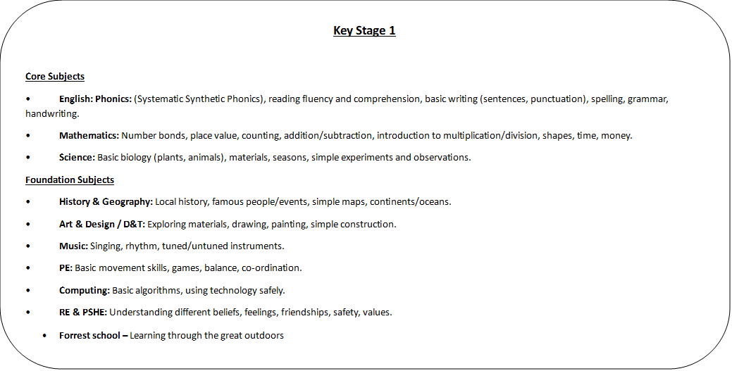

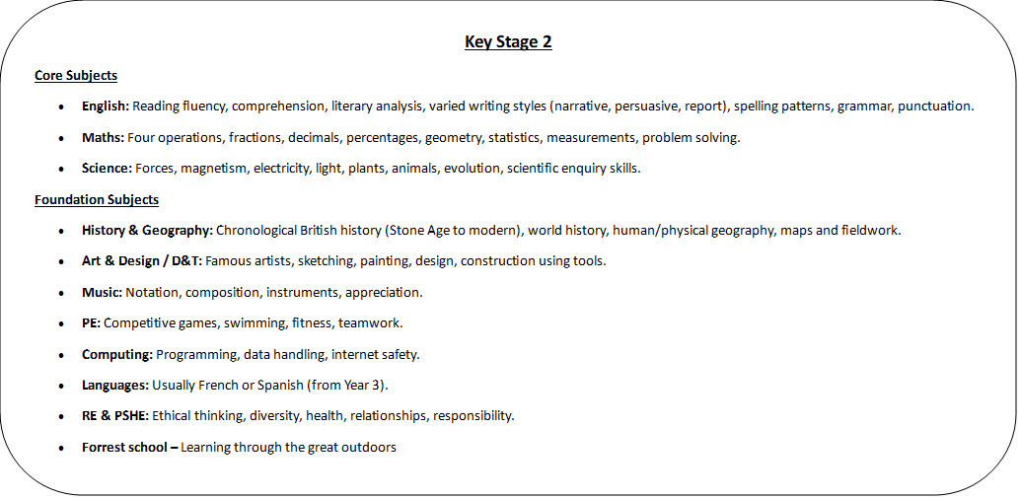

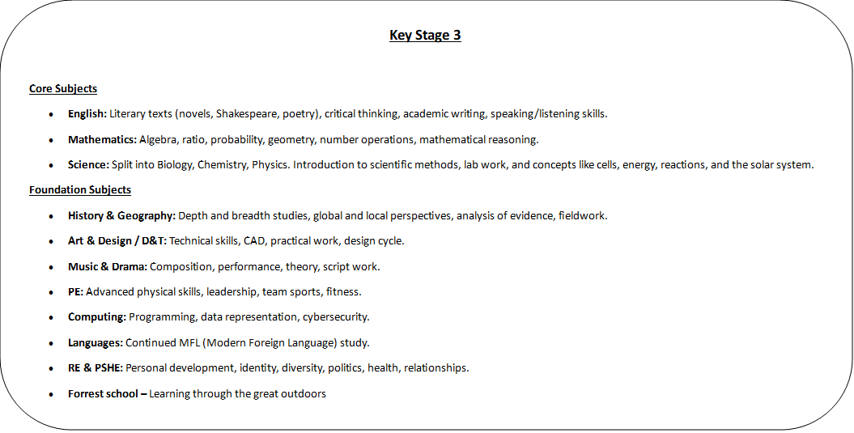

**Curriculum Impact**

Our School’s Curriculum will:

* fulfil all statutory requirements
* be based on National Curriculum definitions of subject breadth and progression wherever possible
* enable pupils to fulfil their potential
* meet the needs of pupils of all abilities
* be delivered in a supportive, therapeutic environment
* provide equal access for all pupils to a full range of learning experiences beyond statutory guidelines
* prepare pupils to make informed and appropriate choices at points of transition
* help pupils develop lively, enquiring minds, an ability to question and argue rationally and an ability to apply themselves to tasks and physical skills
* foster teaching styles which offer and encourage a variety of relevant learning opportunities
* help pupils to use language and number effectively
* help pupils develop personal moral values, respect for religious values and tolerance of other
* races’ beliefs and ways of life
* help pupils understand the world in which they live
* meet the social, emotional and behavioural needs of our pupils
* incorporate a specific curriculum for Key Stage 3 which will focus on the core skills of numeracy and literacy and develop the personal, learning and thinking skills of all pupils

At Benton House School staff will use an online platform called Evidence for Learning to record pupil attainment and assessments across all subjects taught at the school. This system uses the Benton House Progress Steps Assessment Framework. Benton House Progress Steps cover a broad range of ability, from Development Matters that cover Early Years education, through to the Curriculum from Year 1 through to Year 9. This helps to provide staff with additional guidance on the sequence and progression of knowledge and skills within the curriculum, and to ensure that learning builds upon prior attainment. Each Step of the framework represents the corresponding academic year. The expectation for progress for students is that they will cover 80% of the curriculum each year to achieve mastery of that step, before moving on to the next step. Within the framework, pupils are assessed at three levels against each objective – emerging, developing or secure. Teachers use their judgment and evidence from work completed to assess pupil progress. Our expectation is that no child is judged to be secure in their knowledge of an objective until there is a minimum of three pieces of evidence completing the given skill.

|  |
| --- |
|  |

